Eddie Sanchez

Date: March 18, 2019

GSP 216: Remote Sensing

Lab 7 Pre-processing

# **Pre-processing Image of Lake Erie & Understanding Algae Blooms through Remote Sensing**

This lab is all about understanding and learning how to pre-process digital images. To define what is pre-processing is we must first define what is image processing. Image processing is the process of correcting an image so it can be used for analysis and to extract as much information from an image. The methods and how much process is used depends on the goals of a project. However, it's common to use radiometric correction methods to correct uneven sensor response and geometric correction methods to correct geometric distortions due to the earth’s surface. A pre-process image are the steps taken before processing or taking steps to correct an image, and it can take longer than the actual analysis depending on the project. Pre-processing involves radiometric calibration, which means that the digital number values are converted to an at-sensor radiance. A lot of images today has already embedded pre-processed images for analysis; however, when images are not pre-processed one must do it themselves to correct any atmospheric corrections, the removal of striping, and other noise artifacts. There are several ways to correct an image in this lab I focused on the contrast stretching and the dark subtraction method as the two main ways of correcting different level images of Lake Erie, Michigan.

In this lab, the main objective is to understand and apply various pre-process methods to an image that may need preprocessing before conducting an analysis. In this lab, I compared the results of the pre-processed images by using the spectral profiles tool in ENVI. The Images used in this lab came from various sensors. I used images from Landsat 8 Operational Land Imager (OLI) Level 1 Data and Landsat 8 surface reflectance Level 2 Data. Both of these photos are over Lake Erie, and they show the algae bloom in the Fall of 2017. The objectives of this lab are to use knowledge from the last lab on processing images and apply them to make corrected images. The importance of having corrected images is very important depending on the analyses of the study. For our purposes, this lab has a concern with harmful algal blooms (HABs) in and the surrounding areas of Lake Erie. These toxic blooms can runoff into the city landscape drinking water sources, and agricultural areas therefore, corrected images are vital to the analysis when looking at the areas were run off may occur. In this lab, I learned to understand how to apply atmospheric correction by using the dark object subtraction correction technique, used different tools to enhance the color ramp and color slice, and use contrast stretching to balance the contrast to emphasize the algae bloom in Lake Erie.

**Methods**

**Pre-processing Methods Include Calibrating Data, Atmospheric Correction (Dark Subtraction), Comparing Reflectance Values/Spectral Profiles, Extract Water Using Threshold, Raster Color Slices/Color Tables, Calibrate, Mask, and Visualize Landsat Thermal Data, and Contrast Stretch.**

The first step in analyzing any type of satellite image is to create the original, working, and final folders on the desktop, after creating the folders the next step is to download the data. I acquired the data from the google drive shared folder. The Landsat 8 images used for this analysis are titled "LC08_L1TP_020031_20170926_20171013_01_T1.tar.gz" (i.e. Level 1) and "LC080200312017092601T1-SC20181003055809.tar.gz" (i.e. Level 2). The image is located in the shared google drive folder, GSP 216, under Lab 7. Once it is download unzip it and saved it into the original folder the next step is to open the image using the ENVI-64-Bit software. For the next steps all layers in the default setting, in ENVI.

The first step in the actual process of the lab is to pre-process the Level 1 image by using the radiometric calibration tool. This tool is used to correct the scale. Each calibration within this lab makes a new file to the image, making the folder size very large and processing may take additional time. By default, the scale factor will be set wrong, in order to fix it set it to “10000” this will allow comparing the calibrated image (“TOA_Reflectnace.dat”) with the Level 2 image. Once calibration is done, the next step is to use ENVI library tool, to view the quick stats of the image, the image has minimum values meaning that the lowest pixel value or digital number is used for atmospheric correction or can it also be interpreted as the lowest reflectance value. The minimum values are determined by the noise level or a distorted image. Therefore to correct the noise distortion one will need to correct them by setting the minimum value to each color band. Once all seven bands have their corresponding minimum values the next step is to make the Level 1 image into an atmospheric corrected image, by using the dark subtraction method. The minimum values for each of the color bands are used to indicate whether to search for dark areas or in the whole image. To do this insert the minimum values for each color bands and save image as “corrected.dat”. This made the image look slightly brighter and added a black background to the original image. There should be three images in the table of contents, the original un process Level 1 image, the “TOA_Reflectance.dat” is calibrated but not atmospheric corrected, and the third is the calibrated and atmospheric corrected named “corrected.dat”.

The next step in the analysis is to compare the spectral reflectance values and spectral profiles of the images. First, by selecting the Level 2 image and rename it “Level 2 Surface Reflectance.dat” and by clicking on the spectral profiles tool icon I added the “TOA_Refelctance.dat” and the “corrected.dat” to make three separate spectral profile curves clicking on the same part of the image. Once this is complete, I selected two places on the Level 2 Surface Reflectance image, I selected the clear water centered in Lake Ernie and the algae bloom closer to left side of the Lake. The spectral profiles for the clear water shown in Figure 1. describes the reflectance of clear water, the Top of the Atmosphere (TOA), and Atmospherically corrected reflectance. The spectral profiles for the algae bloom shown in (Figure 2.) describes the reflectance of clear water, the Top of the Atmosphere (TOA), and Atmospherically corrected reflectance.

Once that is complete the next step is to analyze the algae bloom. This is done by making a region of interest ROI named “Water.dat” using the band threshold option, meaning this will allow selecting areas of an image where there is water reflectance throughout the urban landscape in the NIR and SWIR bands shown in (Figure 3). This is useful to detect where the runoff can be located. Once we are able to detect where the runoff is occurring the next step is to make a colored slice and table image to easily detect the temperature of the Lake Erie, that way one can easily detect the temperature changes of water with and without algae. To make a thermal color slice image I used the previous ROI layer and changed the green color bands and edit that color band in the window. I changed the classification grouping to 8 and color scheme to start with white as low temperatures and red as high temperatures. Once that is complete the step for this image is to calibrate the thermal data. To calibrate the data I used the radiometric tool and make the “water.dat” ROI layer made from the previous step, after I selected the Thermal Infrared 1 band to alter, and changed the color table (Figure 4.). The next step is to make a contrast stretch that looks the best for the original corrected image. To do this I selected on the “corrected .dat” image and selected the contrast stretch toolbar, I selected a contrast of 2% shown in (Figure 5).

**Results**

For this report, I took a look at two different images of Lake Erie located in Michigan. Both of these images were taken in the same area, however, they were from different Landsat 8 levels. When comparing the Level 2 image and the “corrected.dat” has sutled changes in greens and blues, but that doesn’t mean there are differences. To see changes used the spectral profile tool. The spectral profiles curves created in this lab helped me analyze which location of water has the lowest and which has the highest reflectance. From my own analysis, I can state that spectral reflectance of the water with algae blooms had an overall higher reflectance than the clear water shown in (Figure 1). There is a higher reflectance within the algae blooms of the lake water because vegetation has a greater reflectance than clear water shown in (Figure 2).

When comparing images that were calibrated and “TOA_Refleacted.dat” atmospheric “corrected.dat”. The calibration process made the image brighter in comparison to the original. The atmospheric corrected image also had some settled changes but the changes were seen better in the spectral profile tool. When making a color slice image by using the ROI “Water.dat” layer, the Water.dat layer makes all areas of interest red. Looking at this image it is a great tool to isolate certain areas of interest for example snow. This method could be used to isolate certain patches of snow to only process this snow area. From this analysis, the color table made the algae concentration in the image look more vibrant shown in (Figure 3). The reflectance of green is due to the vegetation on the water, this reflectance in the green wavelength was used as a proxy for chlorophyll concentrations. However, this method is there not much control over setting the classes and the maximum and minimum values. To have more control it's best to use the color slice tool in ENVI. The color slice image when applied a color scale shown in (Figure 3.), the low reflectance are white and the highest reflectance is green. The greener the water looks the higher chlorophyll contraction it is. One thing I would not for next time is not to use colors that can blend in with the background, the white parts look they it blends in with the urban landscape and that was not my intention.

When analyzing the surface temperature layer. What happens to this layer is that the brightness temperature takes the raw values that were collected and sensor and then calibrates them to surface temperature in Kelvin. This layer only looks at the thermal band, it first becomes a black and white striped image, and needs to apply a color table or color slice shown in (Figure 4.). This layer shows how higher temperatures in Red and lower temperatures in green. The thermal 1 band is the best to estimate surface temperatures. In a raster color slice option, the default setting of the classification sets it one degree. This means that each class is one degree warmer than the other one. For my analysis most of the lake there is not a huge change in temperature. However, this could be used in areas where it's known to have huge changes in surfaces for instant elevation.

The last results in my analysis is the Contrast Stretch image, shown in (Figure 5). The default contrast stretches that ENVI does is the linear 2% gives an overall contrast. However other contrast stretches can the color individually. I chose the default linear 2% stretch because I feel it looks the best of balancing all the color bands, with an emphasis on the algae bloom. It was than the original image and I felt it was the best to use as my final image.

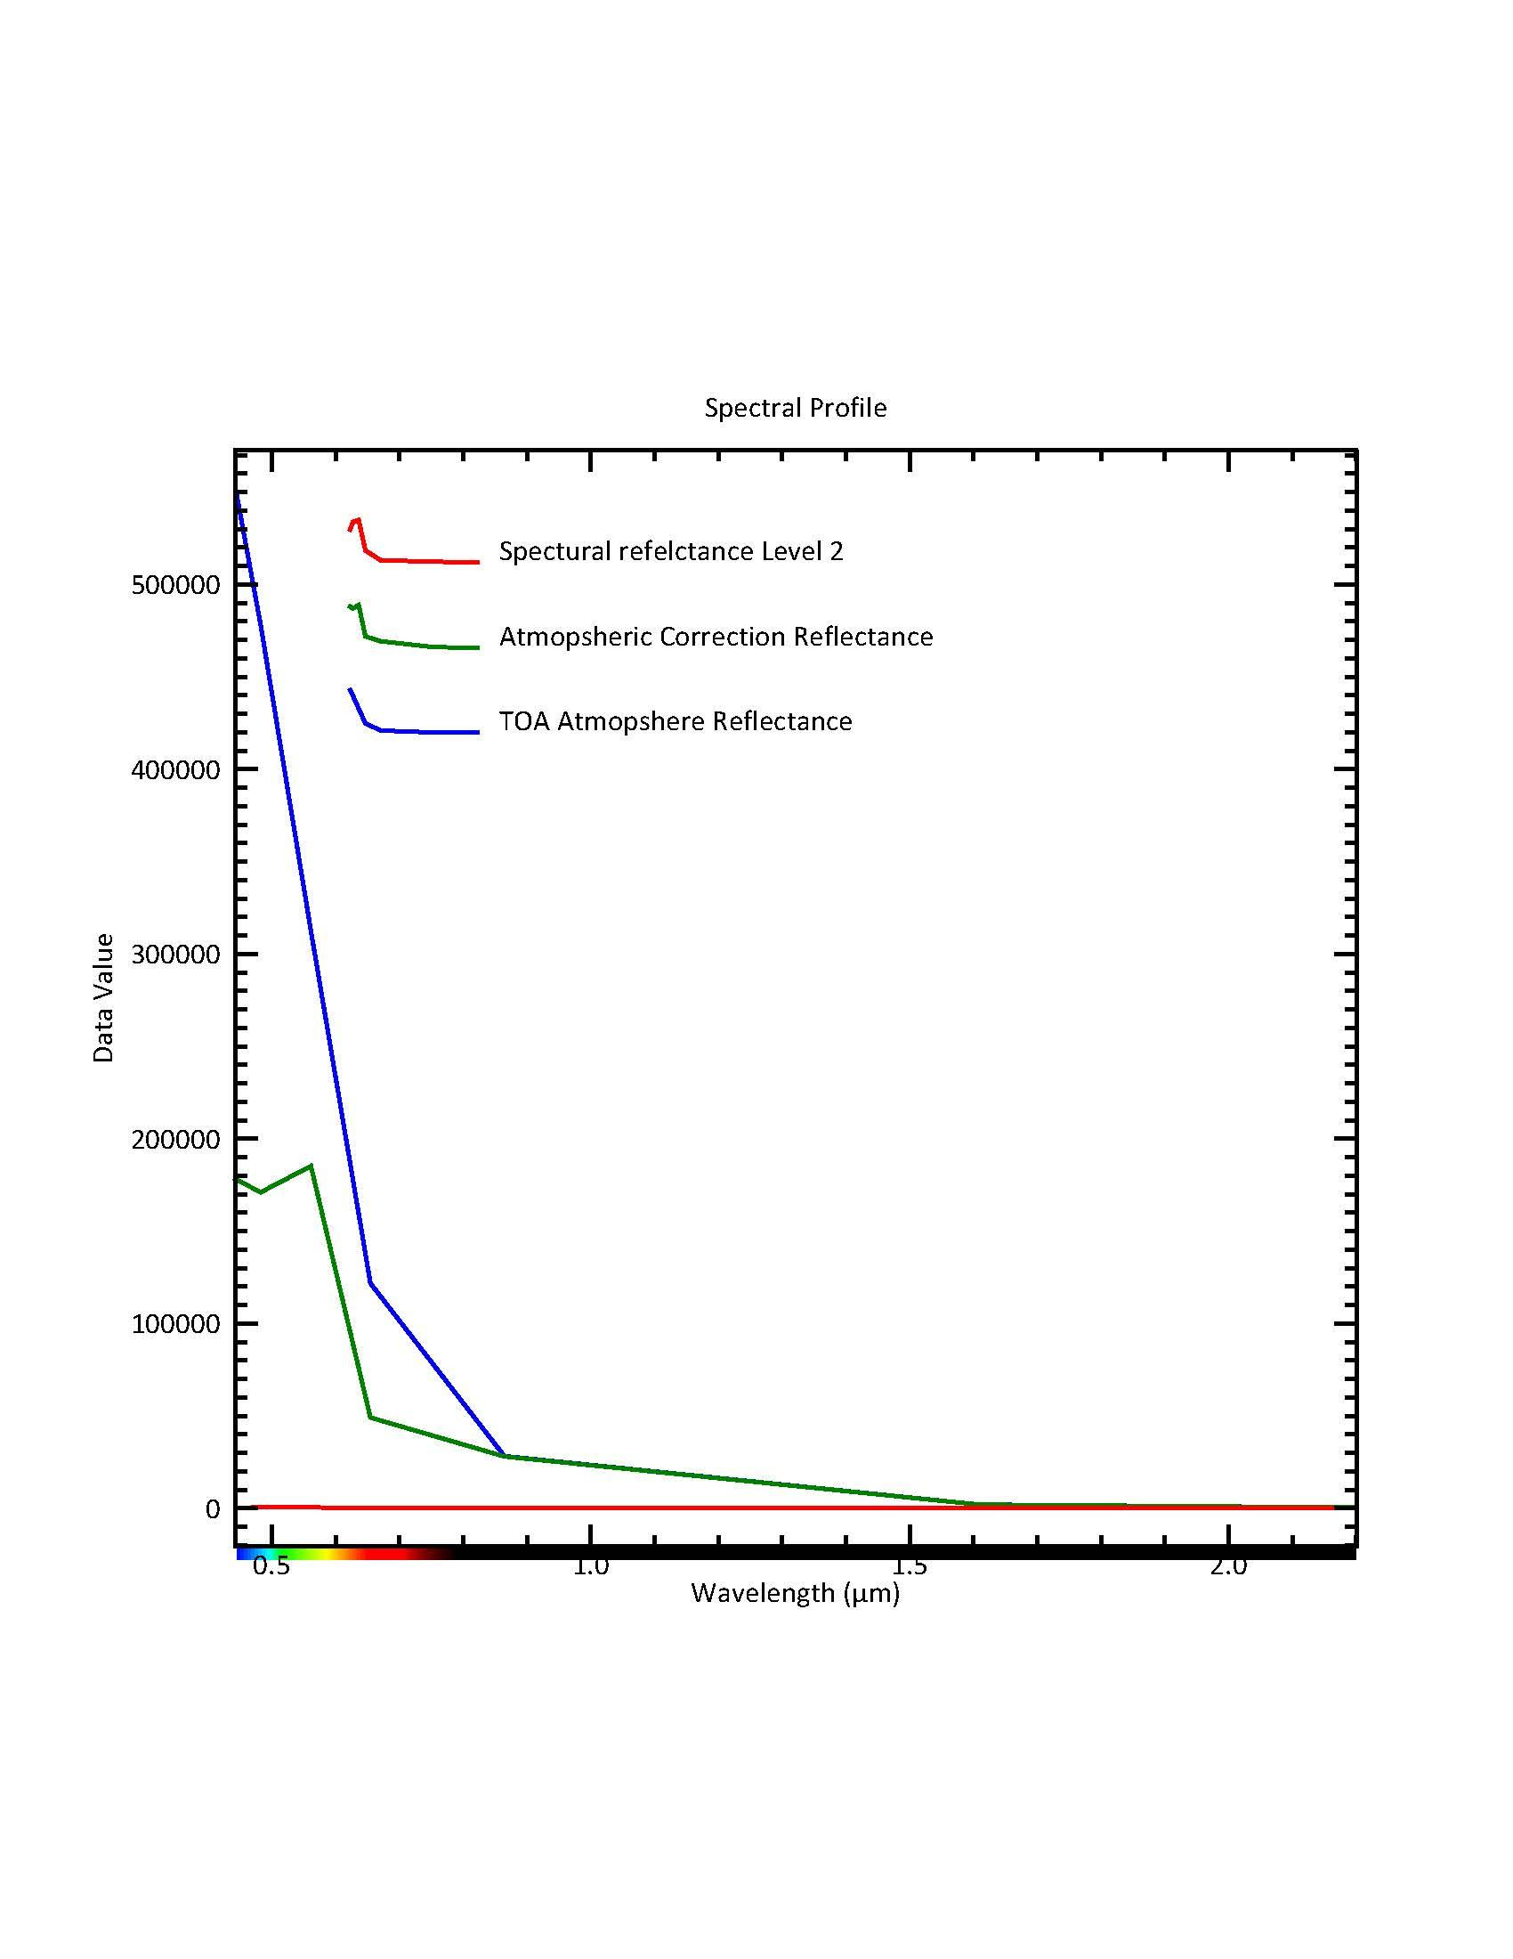

**Figure 1. Spectral Profile For Clear Water, shows the highest reflectance in the visible and low in the Infrared parts of the spectrum**

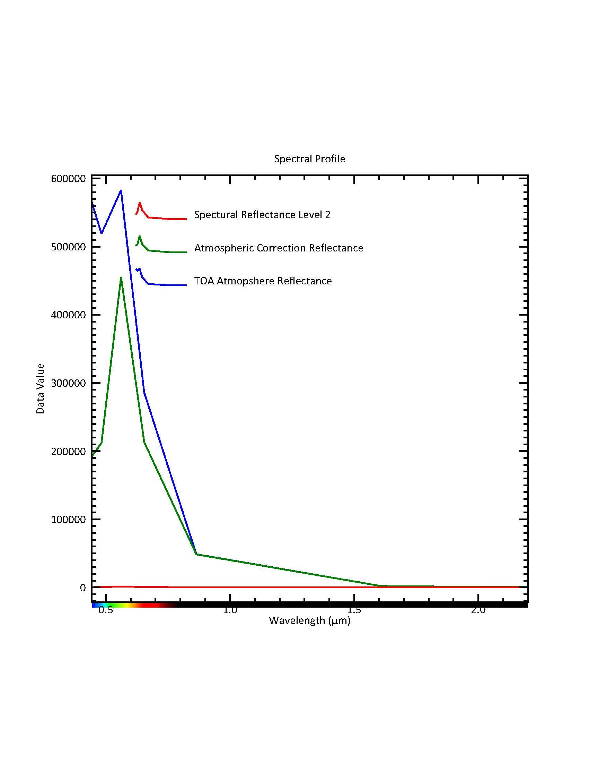

**Figure 2. Spectral Bands For Algae Water, Shows the highest Reflectance in the Visible and Lowest reflectance in the Infrared part of the spectrum.**

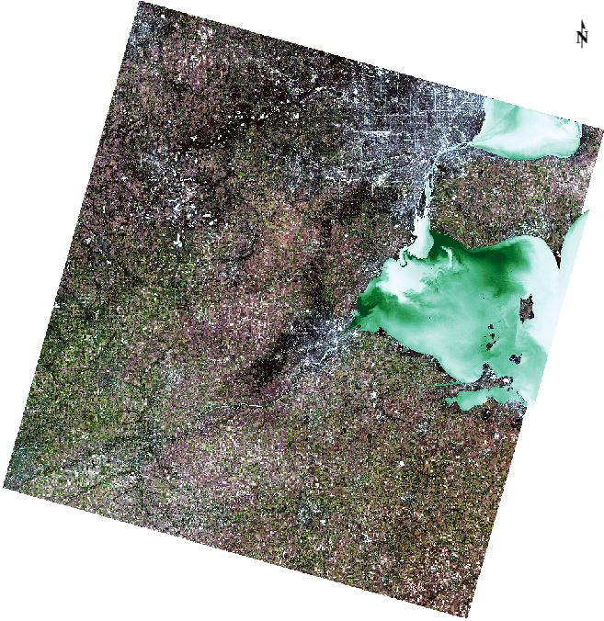

**Figure 3. Landsat Image of Lake Erie’s Algae Bloom Concentrations. Low contractions in white to high contractions in dark green.**

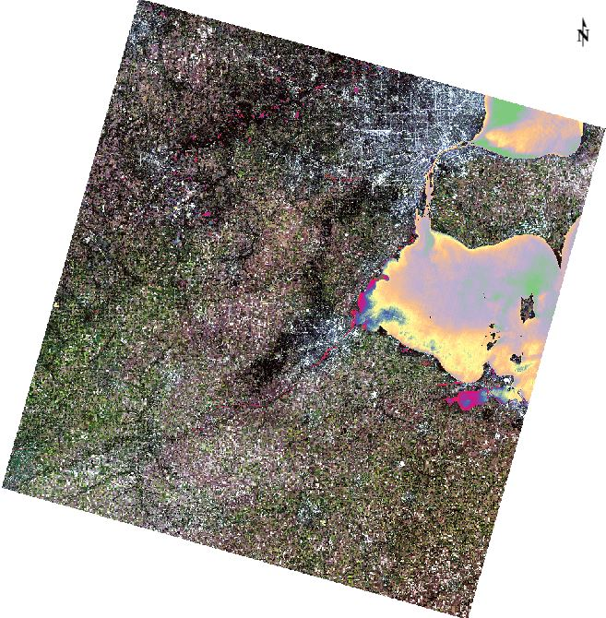

**Figure 4. Surface Water Temp With a Contrast Stretch of 2%**

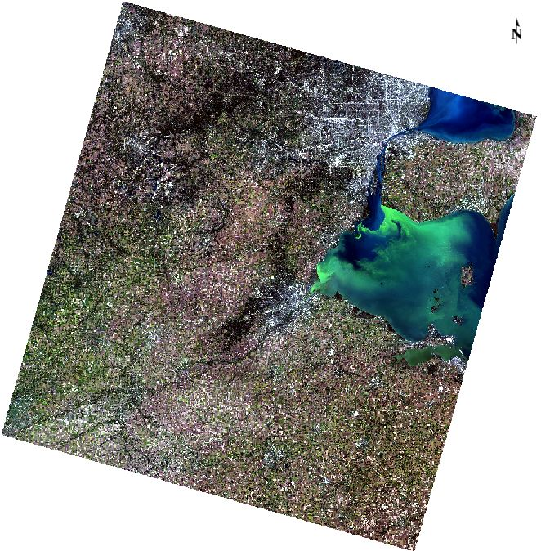

**Figure 5. Contrast Stretch 2% of Original Level 1 Image**

**Discussion**

From my analysis, I saw some image processing differences occur throughout the first steps of this lab. I could tell that the “corrected.dat” was a bit brighter than the “TOA_refelactance.dat” image. I didn’t see a whole lot until the uses of the spectral profile tool. The spectral profile tool is a great method of distinguishing different spectral curves. I can use this information to look for higher spectral curves within the stream which will indicate algae bloom run-off. Overall I enjoyed seeing the differences and how they can be useful to certain applications.

Another interesting aspect of my analysis of the spectral profile curves is that the Atmospheric correction and Top of Atmosphere corrected reflectance both are much higher in the algae bloom water than in the clear water. This because there is more overall Rayleigh scattering happening in the red and blue wavelengths. The biggest differences I saw between the profiles occurred in the visible part of the spectrum, and both of the profiles got closer when reaching the infrared part of the spectrum. And both of the profiles merged all the spectral curves to equal 0.0 in the far end of the infrared spectrum indicated there is no reflectance in that part of the spectrum. Generally, the value will get smaller, and this is due to atmospheric scattering is the strongest at shorter wavelengths means there needs to be more subtraction done at shortwave lengths and less atmospheric scattering in the infrared part of the spectrum. The histograms are useful in changing the colors bands and reclassifying an image. Earlier in the lab, we saw that the colors are all skewed to the left part of the visible part of the spectrum on the histogram. To fix this it needs to have a contrast stretch to stretch out the values.

Lastly, in my analysis, I would like to discuss why the algae all were concentrated to one location and reason why they occur. The reason for why it occurs according to Soonties (2018) suggest that the reason why the blooms occur was because of agricultural pesticide runoff. Large concentrations of pesticides runoff may be coming from West of the Lake because the currents or water lines by accumulating more algae at the lower corner of the lake. Somethings that can be done to help monitor the algae bloom is to make a transportation model. Soonties (2018) suggest algal bloom transport model for Lake Erie that uses a combination of remote sensing and hydrodynamic modeling. By having a transport model this can help by predicting the movement of the algae blooms in addition this mode takes into consideration the currents of the lake, wind, and temperature (Soonties, 2018). In addition, this model can be used to predict the peaks of algae temperature increases when the weather gets warmer. For instance, Soonties (2018) suggest the hydrodynamic model show that this coupled system shows promise in providing accurate predictions of water levels, lake surface temperature, precipitation, evaporation and more. However, in the article it did not mention was of reducing the algae blooms only monitoring its movement and predicting when it can bloom.

**Refecences**

Soontiens, N., Binding, C., Fortin, V., Mackay, M., & Rao, Y. R. (2018). *Algal bloom transport in Lake Erie using remote sensing and hydrodynamic modeling: Sensitivity to buoyancy velocity and initial vertical distribution. Journal of Great Lakes Research*. Retrieved From<https://www-sciencedirect-com.ezproxy.humboldt.edu/science/article/pii/S0380133018301874>

**Acknowledgments**

Humboldt University GSP 216 Lab

Google Share Drive (Obtain Raster Images)

Landsat 8 Level 1 & 2